GOVERNMENT POLYTECHNIC KADUR DEPARTMENT OF COMPUTER SECINCE AND ENGINEERING

ONLINE COURSE REPORT ON:
- INTRODUCTION TO ARTIFICIAL INTELIGENCE
- STATISTICS ESSENTIALS WITH PYTHON



SUBMITTED BY: OBTAINED MARKS:
NAME : VASUDEVAN REG NO : 197CS24045 SEMESTER : 5TH SEM
40
SUBJECT : FULL STACK DEVELOPMENT

SIGNATURE:

INFOSYS SPRINGBOARD

INTRODUCTION:



Infosys Springboard is a free digital learning platform developed by Infosys to provide quality education and industry-relevant skills to students, teachers, and professionals. The platform offers self-paced learning through video lectures, reading materials, practical exercises, and assessments. It helps learners enhance their technical knowledge and prepare for future careers. The platform covers a wide range of subjects, including programming, artificial intelligence, data science, cloud computing, cybersecurity, communication skills, and professional development. Learners can access high-quality content created by industry experts and academic partners at no cost. Infosys Springboard also provides certification opportunities upon successful completion of selected courses, helping learners showcase their skills.

KEY FEATURES:
- Free access to courses:
offers a wide range of free courses in technical and professional skills.
- Self-paced learning:
learn anytime and anywhere at your own convenience.
- Video lectures and study materials:
provides videos, notes, and learning resources for better understanding.
- Quizzes and assessments:
includes quizzes to test knowledge and monitor progress.
- Digital certificates:
awards certificates after successful completion of eligible courses.
- Industry-relevant content:
courses are designed to help learners develop practical skills that are useful for academic and professional careers.
- User-Friendly Interface:
The platform has a simple and easy-to-use interface, making learning accessible for users of all skill levels.

COURSE OVERVIEWS

SL NO | COURSE NAME | AUTHOR | DURATION
1 | INTRODUCTION OF ARTIFICIAL INTELLIGENCE | INFOSYS WINGSPAN | 6H 18M
2 | STATISTICS ESSENTIALS WITH PYTHON | IIHT | 4H 33M


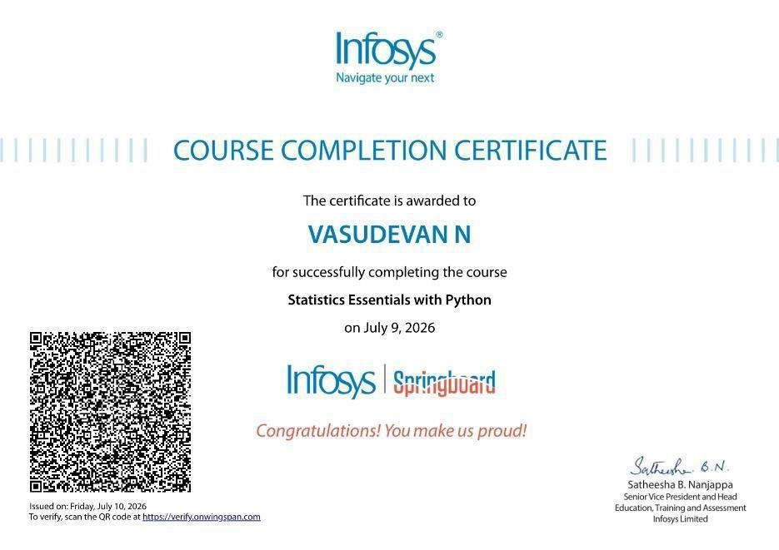

ARTIFICIAL INTELLIGENCE

Introduction to Artificial Intelligence:



Artificial Intelligence (AI) is a branch of computer science that focuses on developing intelligent systems capable of performing tasks that normally require human intelligence. These tasks include learning from experience, reasoning, problem-solving, understanding natural language, recognizing patterns, decision-making, and adapting to new situations. AI combines computer science, mathematics, statistics, and data science to create systems that can think, learn, and improve their performance over time.

In recent years, AI has become one of the fastest-growing technologies in the world. It is widely used in industries such as healthcare, banking, education, agriculture, transportation, manufacturing, e-commerce, and entertainment. AI-powered systems help organizations automate repetitive tasks, improve accuracy, reduce costs, and make better decisions based on data. As technology continues to evolve, AI is becoming an essential skill for students and professionals who want to build successful careers in the digital world.

Learning Outcomes

After completing this course, I was able to:

- Understand the fundamental concepts and principles of Artificial Intelligence.
- Identify various real-world applications of AI across different industries.
- Explain the basics of Machine Learning, Deep Learning, and Neural Networks.
- Recognize the business value and advantages of AI technologies.
- Understand ethical AI practices and the importance of responsible AI.
- Gain knowledge about career opportunities in Artificial Intelligence and Data Science.

Why Artificial Intelligence?

Artificial Intelligence has become an important technology because it helps organizations improve efficiency and productivity. AI can process huge amounts of data within seconds, identify patterns, and generate accurate predictions that support better decision-making. It reduces human errors, automates repetitive work, and allows employees to focus on more creative and strategic tasks.

Some major advantages of AI include:

  - Automates repetitive and time-consuming tasks.
  - Improves decision-making using data-driven insights.
  - Increases productivity and operational efficiency.
  - Reduces human errors and improves accuracy.
  - Provides 24/7 customer support through AI chatbots.
  - Enables personalized recommendations in online platforms.
  - Supports innovation by solving complex real-world problems.
  - Enhances security through fraud detection and cybersecurity systems.

Machine Learning Basics:

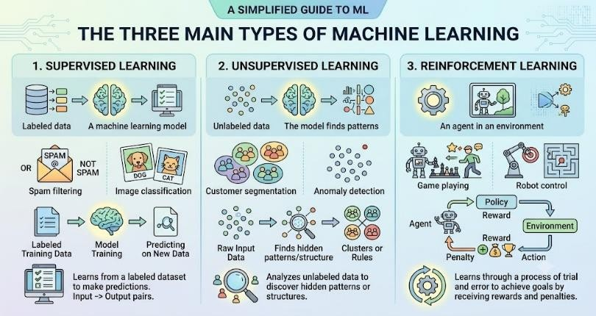

Machine Learning (ML) is a subset of Artificial Intelligence that enables computers to learn from data without being explicitly programmed. Instead of following fixed rules, machine learning algorithms identify patterns from historical data and use those patterns to make predictions or decisions when new data is provided.

Types of Machine Learning

Supervised Learning:
Supervised Learning uses labelled data where both the input and expected output are known. The algorithm learns the relationship between input and output data during the training process and uses this knowledge to predict outcomes for new, unseen data. It is commonly used for classification and regression problems in

REAL-WORLD APPLICATIONS:

  - Email spam detection
  - House price prediction
  - Student performance prediction
  - Medical diagnosis

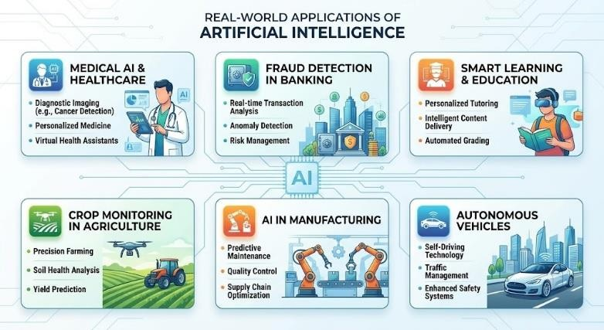

Real-World Applications of AI

AI is transforming industries by improving efficiency and enabling smarter decisions.

- Healthcare: Helps in disease diagnosis, medical image analysis, patient monitoring, and drug discovery.
- Education: Provides personalized learning, automated grading, and virtual tutoring.
- Banking and Finance: Supports fraud detection, risk analysis, customer service, and financial forecasting.
- Agriculture: Helps monitor crops, detect diseases, predict weather, and improve productivity.
- Manufacturing: Enables robotics, quality inspection, predictive maintenance, and automation.
- Transportation: Supports self-driving vehicles, traffic management, and route optimization.
- E-Commerce: Provides product recommendations, customer analysis, personalized advertisements, and chatbot support.

What I Learned

This course helped me develop a strong understanding of Artificial Intelligence, Machine Learning, and Deep Learning concepts along with their practical applications. The major learning outcomes from this course are:

Understanding AI, ML, and Deep Learning:
I learned the differences between Artificial Intelligence, Machine Learning, and Deep Learning. AI is the broader concept of creating intelligent systems, Machine Learning enables systems to learn from data, and Deep Learning uses neural networks to solve complex problems.

Machine Learning Algorithms:

I gained knowledge about different machine learning approaches such as supervised learning, unsupervised learning, and reinforcement learning. I understood how algorithms like Decision Tree, Support Vector Machine, K-Nearest Neighbours, Logistic Regression, and Random Forest are used for prediction and classification tasks.

Generative AI:

I learned about Generative AI and how advanced AI models can create new content such as text, images, videos, and computer code. These technologies are improving creativity, automation, and productivity in many fields.

AI Applications in Real-World Industries:

I understood how AI is applied in healthcare, education, banking, agriculture, manufacturing, transportation, and e-commerce to improve efficiency, automate processes, and support better decision-making.

AI Ethics and Responsible AI:
I learned the importance of developing AI systems that are fair, transparent, secure, and responsible. Ethical AI practices help prevent bias, protect privacy, and ensure that AI benefits society.

Career Opportunities in AI:

The course introduced various career paths in Artificial Intelligence and Data Science, including AI Engineer, Machine Learning Engineer, Data Scientist, Robotics Engineer, NLP Engineer, and AI Research Scientist.

Conclusion

Artificial Intelligence is transforming the modern world by improving productivity, automating complex tasks, and enabling intelligent decision-making. Through this course, I gained knowledge of AI concepts, machine learning techniques, deep learning models, and ethical AI practices. These skills will help me understand future technologies and prepare for career opportunities in the growing fields of Artificial Intelligence and Data Science. AI will continue to drive innovation across industries and play an important role in building smarter and more efficient solutions.

STATISTICS ESSENTIALS WITH PYTHON

INTRODUCTION TO DATA SCIENCE:

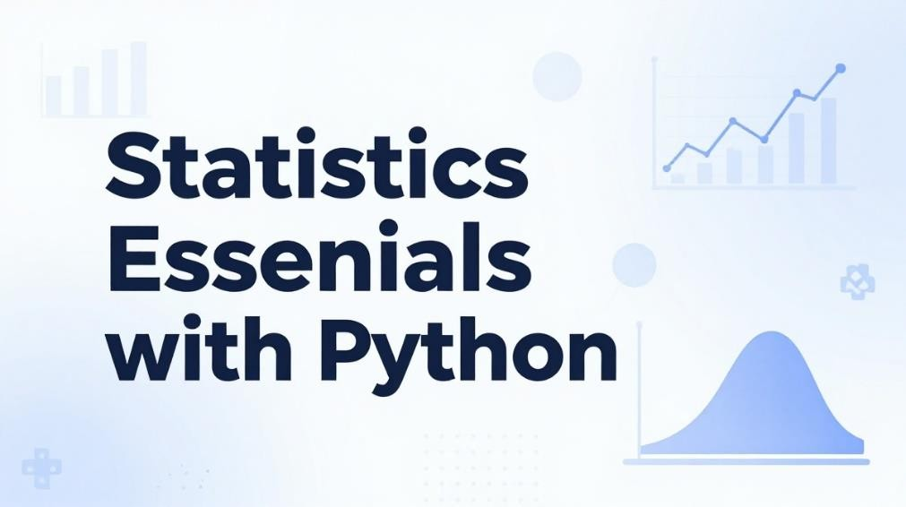

Data science collects, processes, analyses, and interprets data to discover meaningful insights. It combines statistics, programming, machine learning, and data visualization to solve real-world problems and support data-driven decision-making, and is widely used across healthcare, finance, education, and business.
  - Collects and analyses large amounts of data
  - Uses programming languages such as python and r
  - Combines statistics, machine learning, and visualization
  - Helps organizations make better decisions
  - Identifies patterns and predicts future trends
  - Creates interactive dashboards and reports for better insights
  - Improves business efficiency by optimizing processes and reducing costs

BASIC CONCEPT OF STATISTICS:
Statistics is the branch of mathematics focused on collecting, organizing, analysing, interpreting, and presenting data. It helps summarize information, identify patterns, and support accurate decision-making, and is fundamental to data science, research, and business analytics.
  - Used to collect and analyse data
  - Divided into descriptive statistics and inferential statistics
  - Measures of central tendency: mean, median, and mode
  - Measures of dispersion: range, variance, and standard deviation

CALCULATING MODE:
Mode is a measure of central tendency representing the value occurring most frequently in a dataset. It applies to numerical or categorical data, and a dataset may be unimodal, bimodal, multimodal, or have no mode at all.
  - Mode is the value with the highest frequency
  - Can be used for both numerical and categorical data
  - A dataset can be unimodal, bimodal, or multimodal
  - If no value repeats, the dataset has no mode
  - Simple to calculate and interpret

CALCULATING DISPERSION MEASURES
MODE = VALUE WITH THE HIGHEST FREQUENCY
Dispersion measures (range, variance, standard deviation) show how spread out data values are; lower dispersion means greater consistency. Range = max − min; variance = avg. Squared deviation from mean; sd
= √variance.

HISTOGRAM CALCULATION
A histogram displays the frequency distribution of numerical data by grouping values into bins, revealing shape, spread, and outliers. Frequency = number of observations per bin.

CORRELATION FUNCTION

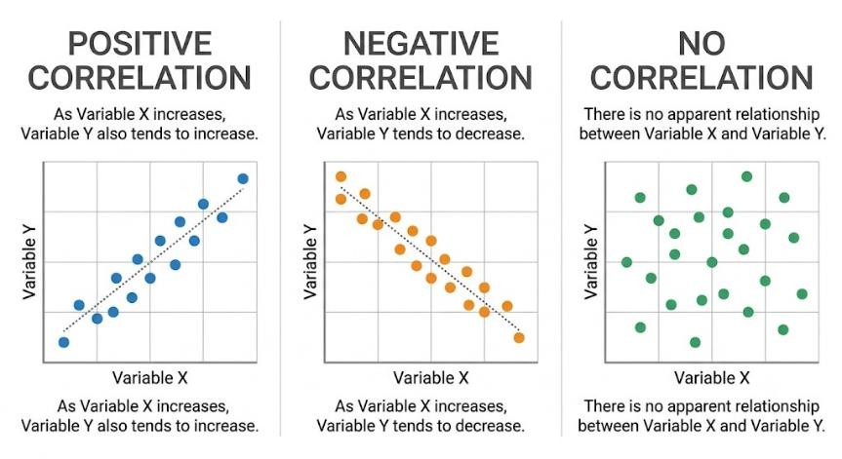

Correlation measures the strength and direction of the relationship between two variables, ranging from -1 to
+1 (0 = no correlation). Pearson's r = cov(x, y) / (σx × σy).

PANDAS DATAFRAME
A pandas data frame is a two-dimensional python data structure for storing and organizing data in rows and columns, supporting filtering, sorting, and handling missing values. Common operations: create a data frame, read csv/excel, filter/sort records, add or remove columns.

HYPOTHESIS TESTING
Hypothesis testing checks whether a claim about a population is supported by sample data, testing the null (h₀) vs. Alternative (h₁) hypothesis using t-test, z-test, or chi-square test. Steps: state hypotheses, set significance level (α), choose test, calculate statistic, accept/reject h₀.

NUMPY PACKAGE
NumPy supports fast numerical computing with multi-dimensional arrays, using less memory than python lists. Key functions: array(), mean(), median(), add(), multiply(), sqrt(), reshape().

FINDING THE MEASUREMENT
Key statistical values — mean, median, mode, and range — summarize a dataset's characteristics and support comparison between datasets.

CALCULATING THE DENOMINATOR
The denominator is the total number of observations, used in formulas such as mean = σx / n and probability
= favourable outcomes / total outcomes.

IMPLEMENTING TEST SCENARIOS
Test scenarios verify that statistical methods produce accurate results: define the objective, prepare sample data, execute the method, compare results, and record observations.

USING EXCLUSIVE EVENTS
Mutually exclusive events cannot occur at the same time (e.g., a coin toss — head or tail); p(a or b) = p(a) + p(b).

ORDINARY LEAST SQUARES (OLS) REGRESSION
Ols regression finds the best-fit line minimizing the sum of squared differences between actual and predicted values: y = β₀ + β₁x + ε.

ANALYSING THE TEST STATISTICS
Analysing test statistics compares the calculated statistic (z, t, or chi-square) with the critical value or p-value to accept or reject the null hypothesis.

OUTPUT OF THE VARIABLES

Model output includes predicted values, coefficients, intercept, 𝑟²value, p-value, and standard error. These values help explain how variables are related and how accurate the model is. Predicted values show the expected result, coefficients show the effect of each variable, and the intercept gives the starting point. The 𝑟²value shows how well the model fits the data, while the p-value tells whether the relationship is statistically significant. Standard error shows the reliability of the estimates.

MULTIPLE EXPLANATORY VARIABLES
Multiple regression uses several independent variables together to improve prediction accuracy: y = β₀ + β₁x₁
+ β₂x₂ + ... + βₙxₙ + ε.

FITTING THE MODEL
Model fitting trains a model on data to learn variable relationships, then evaluates performance using r², mse, rmse, and mae to reduce overfitting and underfitting.

CURVE FITTING AND REGRESSION FIT LINE

Curve fitting finds the best mathematical curve or line for the data. The linear regression fit line is y = β₀ + β₁x, where β₀ is the intercept and β₁ is the slope. It helps identify the relationship between variables and predict future values.

WHAT YOU LEARN

    - DATA SCIENCE BASICS: WHAT DATA SCIENCE IS AND HOW IT HELPS WITH DECISION-MAKING.COURSERA
    - STATISTICS BASICS: MEAN, MEDIAN, MODE, RANGE, VARIANCE, AND STANDARD DEVIATION.SKILLSETMASTER
    - NUMPY: HOW TO WORK WITH ARRAYS AND DO FAST MATH OPERATIONS.SKILLSETMASTERYOUTUBE
    - PANDAS: HOW TO USE DATAFRAMES TO CLEAN, SORT, FILTER, AND READ DATA.SKILLSETMASTERYOUTUBE
    - CORRELATION: HOW TO CHECK WHETHER TWO VARIABLES ARE RELATED.REALPYTHON
    - HYPOTHESIS TESTING: HOW TO TEST A CLAIM USING SAMPLE DATA AND P-VALUES.COURSERA+1
    - REGRESSION: HOW TO PREDICT VALUES USING ONE OR MORE VARIABLES.COURSERA
    - HISTOGRAMS AND DISTRIBUTIONS: HOW TO SEE PATTERNS IN DATA

CONCLUSION:
Data science combines statistics, programming, and machine learning to study data and find useful insights. It helps convert raw information into meaningful results that can guide better decisions. With tools like NumPy and pandas in Python, data can be cleaned, organized, analysed, and visualized more easily. These methods are useful in fields such as healthcare, finance, education, and business. It also helps predict future trends and improve the overall efficiency of systems.

